Market Flash: Ørsted A/S (ORSTED.CO)

Bearish Positioning Surges to Cycle Highs; Rights-Issue Underscores Stress in Offshore Wind
In our latest EquiLend Data & Analytics Market Flash, we assess the surge in bearish sentiment around Ørsted, driven by a U.S.-linked rights issue and a broader sell-off in renewable energy. Our analysis of securities financing activity highlights extreme positioning and identifies potential stress points for the stock.

Market Context
On August 11, 2025, the Danish wind developer announced a DKK 60 billion rights issue—roughly US $9.4 billion—to fund the entire Sunrise Wind project in the United States. This was prompted after potential co-investors were deterred by the Trump administration’s hostility to offshore wind.
The capital call represents about half of Ørsted’s market value and sent the stock to a record low. Company executives acknowledged that macro headwinds and supply-chain challenges had left them with few options. This macro-political backdrop provides important context for the extreme positioning dynamics we observe in the securities lending market. The equity continues to trend lower, with declines of −32% over 3 months, −38% over 6 months, and −51% over 12 months. The rights-issue announcement accelerated the recent drawdown.
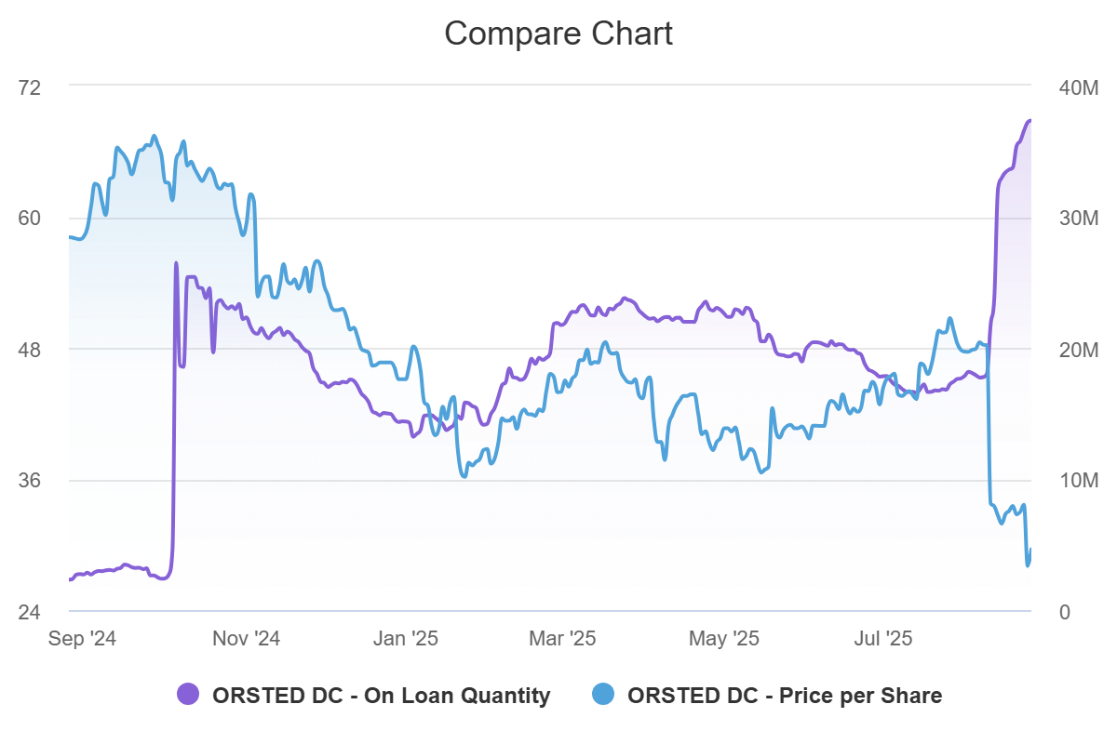

EquiLend Data & Analytics Insights
EquiLend's securities lending data reveals a clear and sustained build-up of bearish sentiment, culminating in a crowded short position.
- Shares On-Loan: On-loan balances rose sharply to a high of 37.19 million shares, the highest level in our 2023–25 sample (≈100th percentile). Lending demand has surged dramatically, more than doubling versus three months ago and up over 1,400% compared to the same time last year.
- Utilization: The utilization rate stands at 83.1%, also at the extreme end of its historical distribution (≈99.7th percentile). The metric has jumped more than 32 percentage points over the past three months.
- Average Borrow Fee: The average borrow fee is 179 bps, near the 99th percentile and up roughly +156 bps (+680%) versus three months ago. The cost of sourcing shares has risen sharply as demand outpaces supply.
- Recent Weekly Flows: The week of August 11 saw a net inflow of +15.35 million shares on-loan, representing a regime shift in sentiment. The week of August 18 added another +3.17 million shares, and early data for the week of August 25 shows a continued inflow of +0.64 million. These inflows illustrate a multi-week build rather than a one-day anomaly.
- Supply Context: Total lendable shares have increased modestly (+17% vs. 3 months ago) as existing holders provide more inventory. However, this growth is far slower than the demand surge, pushing utilization towards capacity and raising fees.

Analysis
The synchronized surge in on-loan balances, utilization, and borrow fees to the top percentile suggests a crowded short is developing or already in place. Such extreme positioning could amplify price moves in either direction.
With utilization near capacity, incremental borrowing may be constrained, implying that additional short sales could become more costly or difficult to execute. This tightness often elevates volatility around news events. While the prevailing price trend remains downward, any upside catalyst—such as favorable policy developments or stronger operational results—could trigger short covering, leading to sharp, short-term rallies. This is not a prediction, but rather an acknowledgment of the asymmetric payoff profile inherent in crowded shorts.
Conversely, the rights-issue underscores that Ørsted needs capital to fund its U.S. projects and reflects ongoing macro challenges facing the offshore wind industry. Continued macro or policy headwinds may therefore sustain pressure on the shares.
Snapshot (25 Aug 2025)
Metric | Level | 3-month change | 6-month change | 12-month change
On loan | 37.19 M | +17.83 M (+92 %) | +15.36 M (+70 %) | +34.72 M (+1,402 %)
Utilization | 83.1 % | +32.38 pts (+64 %) | +30.49 pts (+58 %) | +76.72 pts (+1,206 %)
Borrow fee | 179 bps | +156 bps (+680 %) | +145 bps (+423 %) | +155 bps (+623 %)
Lendable | 44.77 M | +6.56 M (+17 %) | +3.25 M (+8 %) | +5.81 M (+15 %)
Price (DKK) | 28.03 | −32 % | −38 % | −51 %

